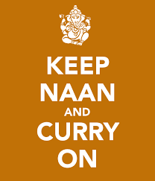
£19.95 for any 2 curries
VEGETABLE – BEEF
and our curry of the day
accompanied with
FLATBREAD RICE
PAKORA
MANGO CHUTNEY & MINT RAITTA

EVERY TUESDAY NIGHT

